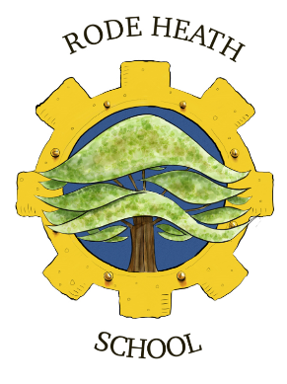 | Rode Heath Primary School  Heath Avenue, Rode Heath,  Stoke on Trent, ST7 3RY  Telephone: 01270 314414  E-mail Address: admin@rodeheath.cheshire.sch.uk  Headteacher: Mr John Frankland  Inspiring learning; nurturing minds; achieving for life | 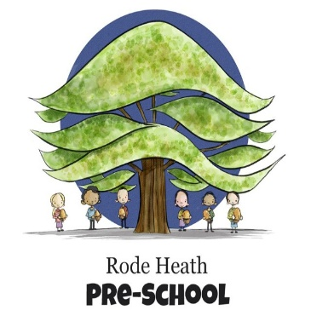

GOVERNANCE STATEMENT 2025

Dear Parents and Carers,

As a governing body, we are proud to have been able to work with the staff and children of Rode Heath Primary School throughout the last academic year. As always, the school’s core values of teamwork, resilience, curiosity and fairness have underpinned everything that has been achieved by both the staff and children. Mr Frankland has continued to build upon his successful first year as Headteacher. The reports that governors have received throughout the year are evidence that the passion to provide a sustainable and effective curriculum for our children is unwavering. None of which is possible without the dedicated and hardworking staff of the school, governors extend our thanks to every member of the team.

As we reported previously, Ofsted undertook a full inspection of the school in March 2024 which resulted in the well-deserved grading of ‘Outstanding’ with no Actions for Improvement identified. As governors, we believe the consistent desire to improve outcomes for all children, through both learning and personal development has continued since this inspection. The team have worked hard to ensure that every child reaches their potential and this is also shown in the fantastic Key Stage 2 results, Year 4 Multiplication Test Check and Reception Early Learning Goals from July 2025. Of course, none of this would be possible without the support of our parent and carer community. Governors extend our thanks to parents and carers for the support with home learning, high attendance rates and extra-curricular competitions.

Over the past year, our children have engaged in a wide range of enriching and inspiring activities. They have initiated and led fundraising projects supporting the RNLI, Dougie Mac, Alder Hey, World Down Syndrome Day, and the NSPCC through events like Maths Number Day. Leadership is encouraged throughout the school, with children taking on roles such as School Councillors and Eco Team members, even planning and delivering assemblies on important topics like environmental conservation and child safety. The ECO Team itself was a child-initiated project, demonstrating the children’s commitment to sustainability. Academically and creatively, pupils have shone through participation in national competitions such as the Explorify Art competition and an exciting Sky Arts Connections Week. Our athletics team proudly won the Sandbach Town Sports Small School Shield and came second overall out of ten schools, while our mixed Year 4–6 football team and cross-country team were both runners-up in their leagues.

Music and performance are also central to school life, with regular Christmas, Harvest, Easter, and Summer productions involving every year group from Pre-School to Year 6. Highlights include a glockenspiel concert by Year 4 and a Christmas concert by the school choir. Children also took part in residential visits from Year 2 upwards. As part of our Careers Awareness initiative, numerous parents visited to speak about their professions, including a veterinarian, a marketing manager, a pharmacist and council workers. Finally, our extra-curricular programme has continued to grow, with children enthusiastically participating in clubs such as yoga, coding, choir, and engineering.

We would like to thank all parents, carers and the school community for their continued efforts as we work together to continue to provide a safe and exciting learning environment for our children.

If you would like to contact us, please feel free to email: chair@rodeheath.cheshire.sch.uk.

Kind regards,
Lisa Asprey and Tara Sanchez, Co-Chair of Governors

