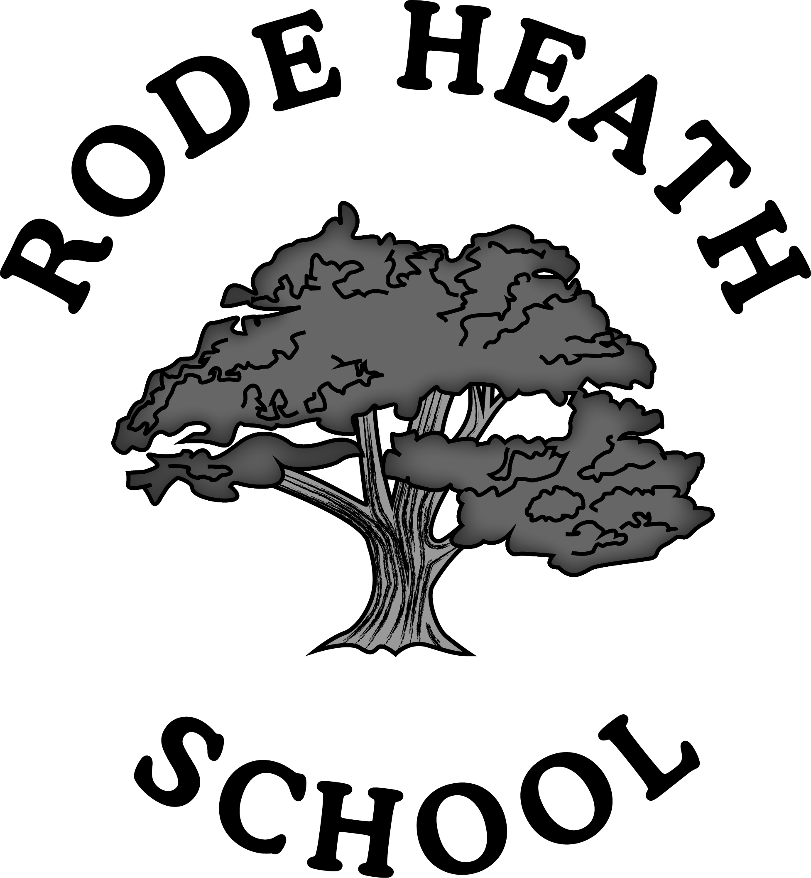

PRIVACY NOTICE
School Workforce: those employed or otherwise engaged to work at Rode Heath Primary School

Privacy Notice – The Data Protection Act 1998 and General Data Protection Regulation 2018 : How we use your information

We collect and process employee information as part of our public functions under both the Data Protection Act 1998 and General Data Protection Regulation.

Rode Heath Primary School process personal data relating to those we employ to work at, or otherwise engage to work at, our school. This is for employment purposes to assist in the running of the school and/or to enable individuals to be paid.

Why do you need my information?

The collection of this information will benefit both national and local users by:

- improving the management of workforce data across the sector
- enabling development of a comprehensive picture of the workforce and how it is deployed
- informing the development of recruitment and retention policies
- allowing better financial modelling and planning
- enabling ethnicity and disability monitoring; and
- supporting the work of the School Teachers’ Review Body
- enabling school to meet its statutory duties in relation to safer recruitment, safeguarding and H&S

The categories of information that we collect, hold and share include:
- Personal information (such as name, NI number)
- Characteristics (such as ethnicity, nationality, country of birth)
- Qualifications
- Next of kin details
- Bank details
- Work related information (including employment contracts, remuneration details, references, absence in relation to sickness and non-sickness related absences)

Collecting information
In order to comply with the General Data Protection Regulation, we will inform you whether you are required to provide certain information to us or if you have a choice in this.

Storing workforce data
We hold workforce data in accordance with our Retention Policy Schedule and Cheshire East Guidance.

How will my information be stored?
We store all data securely on encrypted devices and on the GDPR Platform/SIMS database.

Data collection requirements:
To find out more about the data collection requirements placed on us by the Department for Education (for example; via the school census) go to https://www.gov.uk/education/data-collection-and-censuses-for-schools.

What allows you to use my information?
The submission of the school workforce census return, including a set of individual staff records, is a statutory requirement on schools and local authorities by virtue of regulations made under sections 113 and 114 of the Education Act 2005. This means that:
- although schools and local authorities must meet their obligations to data subjects under the Data Protection Act, they do not need to obtain consent for the provision of information from individual members of the workforce
- schools and local authorities are protected from any legal challenge that they are breaching a duty of confidence to staff members
- schools and local authorities must complete a return.

Who will my information be shared with?
We will not share information about you with third parties without your consent unless the law allows us to.

We are required, by law, to pass on some of this personal data to:
- our Local Authority
- the Department for Education (DfE). The Department has robust processes in place to ensure the confidentiality of our data is maintained and there are stringent controls in place regarding access and use of the data. Decisions on whether DfE releases data to third parties are subject to a strict approval process and based on a detailed assessment of:

- who is requesting the data
- the purpose for which it is required
- the level and sensitivity of data requested:
- the arrangements in place to store and handle the data

For more information about the department’s data sharing process, please visit:
https://www.gov.uk/data-protection-how-we-collect-and-share-research-data
To contact DfE: https://www.gov.uk/contact-dfe

Data will not be used to make automated decisions about you.
Should you move abroad, data may be transferred to your new educational setting.

Requesting access to your personal data
You have the right under the Data Protection Act 1998 (General Data Protection Regulation) to request a copy of your information and to know what it is used for and how it has been shared. This is called the right of subject access.
To make a request for your personal information, or be given access to your child’s educational record, contact:
Mrs Edyta Hicklin, Data Protection Administrator at: sbm@rodeheath.cheshire.sch.uk

You also have the right to:
- object to processing of personal data that is likely to cause, or is causing, damage or distress
- prevent processing for the purpose of direct marketing
- object to decisions being taken by automated means
- in certain circumstances, have inaccurate personal data rectified, blocked, erased or destroyed; and
- claim compensation for damages caused by a breach of the Data Protection regulations

If you have a concern about the way we are collecting or using your personal data, you should raise your concern with us in the first instance or directly to the Information Commissioner’s Office at https://ico.org.uk/concerns/

Contact:
If you would like to discuss anything in this privacy notice, please contact:
Mrs Edyta Hicklin, Data Protection Administrator at: sbm@rodeheath.cheshire.sch.uk

