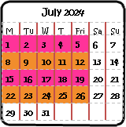
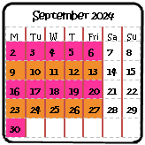
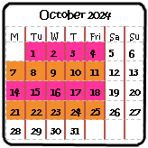
We are taking steps to reduce sugar in our recipes

We can and will cater for all special dietary requirements
We are taking steps to reduce single use plastic

At:
Rode Heath Primary School
Our food is free from undesirable trans fats, sweeteners and additives
Our food is freshly prepared on site by professional staff who care about quality and ingredients
We support local wherever possible…our meat comes from Quality Cuts of Sandbach, Littler’s of Sandiway, Barrows of Bollington and Lower Hurst Farm in Derbyshire.
Our “Food For Life Served Here” menu means we serve
Fresh, local, honest food.
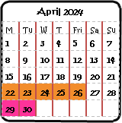
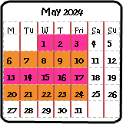
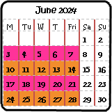
We use free range eggs, organic yogurt, organic Mornflake oats and MSC fish.

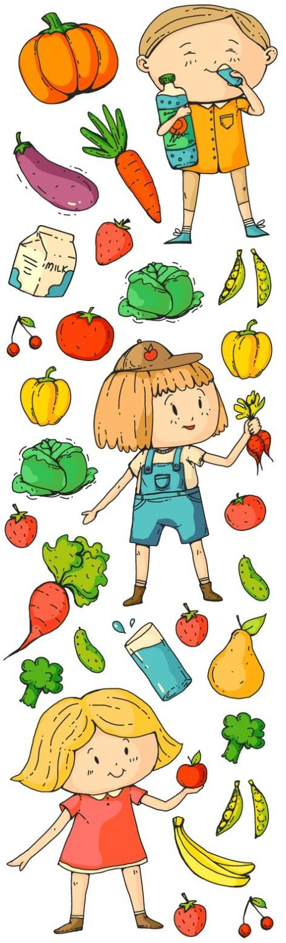
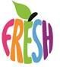
Spring/ Summer Menu 2024

MONDAY
Vegetarian
Sausage Roll,
Potatoes, Veg & Gravy
TUESDAY

Spaghetti Bolognese
With Homemade
Garlic Bread
WEDNESDAY

Butchers Sausage,
Mash Potato, Veg
& Gravy

THURSDAY

Chicken Korma
with Rice

FRIDAY

Fish Fingers
with Chips &
Baked Beans or peas

(v) Pasta Jacket Potato
Italienne with a choice
of fillings

Vegetarian Jacket Potato
Spaghetti with a
Bolognese Choice of
& Garlic Bread Fillings

Plant Friendly Sausage, Mash Potato, Veg & Gravy

Quorn Korma Jacket Potato
& Rice (v) with a choice
Of Fillings

Mini Omelette Popovers with Chips & Beans
or Peas (v)

Orange Cookie,
Yogurt or Seasonal Fruit Platter

Chocolate Penny Biscuits or
Seasonal Fruit
Platter

Ice Cream &
Fruit Coulis or
Seasonal Fruit
Platter

Carrot & Pineapple Cake or Seasonal
Fruit Platter

Chocolate Crunch
Finger & Fruit Chunk
or Seasonal Fruit
MONDAY
Cheese & Tomato
Pizza with Paprika
Potatoes & Salad (v)

TUESDAY

BBQ Pork Wrap
with Savoury
Rice

WEDNESDAY

Roast Chicken
Stuffing, Potatoes
Veg & Gravy

THURSDAY

Chicken & Tomato
Pasta Italienne

FRIDAY

Breaded Fish Star
with Chips & Baked
Beans or Peas

Jacket Potato
With a choice
Of fillings

Ravioli in Jacket Potato
Homemade with a choice
Tomato fillings
Sauce (v)

Roast Quorn Fillet
Stuffing Potatoes,
Veg & Gravy (v)

Cheesy Jacket Potato
Pasta (v) with a choice
fillings

Vegetarian Sausage with Chips & Baked Beans or Peas (v)

Melting Moments, Yogurt or Seasonal Fruit Platter

Tangy Lemon Cake
or Seasonal Fruit
Platter

Fruit Oatie Finger or Seasonal Fruit Platter

Shortbread Finger & Fruit Chunk or Seasonal Fruit Platter

Summer Fruit Flapjack or Seasonal Fruit Platter

FILLED JACKET POTATO AVAILABLE EVERY MONDAY, TUESDAY & THURSDAY
Fillings available Beans, cheese, tuna

