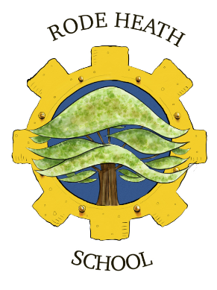 | Rode Heath Primary School  Heath Avenue, Rode Heath,  Stoke on Trent, ST7 3RY  Telephone: 01270 314414  E-mail Address: admin@rodeheath.cheshire.sch.uk  Headteacher: John Frankland  Inspiring learning; nurturing minds; achieving for life | 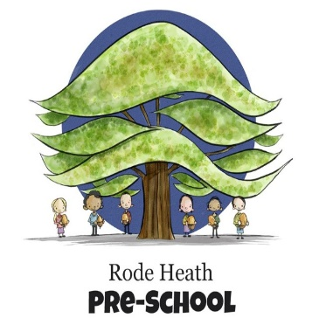

Monday 11th December, 2023

Dear Parents

In the spring term we will be starting a new history topic covering the Ancient Greeks. To launch our studies, we would like to take the class to the Potteries Museum and Art Gallery on Tuesday 16th January 2024. The day will consist of two workshops. During the first session, the children will learn all about Greek gods and everyday life in Ancient Greece, as well as studying Greek pots thousands of years old and learning about their influence through the ages. This will be followed after lunch by an afternoon session in which the children will have the opportunity to make and decorate their own Greek coil pots.

We will be leaving school at 9:15 am and should be back for the end of the school day. The cost of the trip will be £18. This includes a cost of £7 for the coach and £11 for entrance to the museum and workshops. The children will need a packed lunch and a couple of drinks (no cans or glass bottles please!) in a suitable hands-free bag such as a rucksack. The children need to wear school uniform and bring a waterproof coat.

Kind regards

Mrs Wiskow & Mrs Pecora

