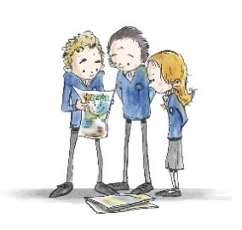
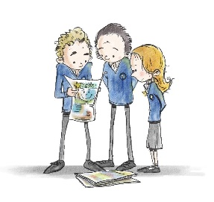School Council- Code of conduct for pupils at Rode Heath Primary School
1) Always show respect; be kind and courteous to other people.
2) Always put 100% effort into everything you do.
3) Demonstrate excellent listening skills.
4) Don’t be afraid to ask for help.
5) Use kind words only and don’t be a bystander.
6) Be inclusive of others and make everyone feel equal and valued.
7) Be respectful to school equipment and the school environment and grounds, including only walking in the corridor.
8) Be resilient- don’t give up!
9) Be prepared and ready to learn with a positive attitude.
10) Be curious and ask relevant questions!
