**Kashmiri Goats**

**Introduction**

Llandudno is a Victorian seaside town in north wales. The town has been a holiday town for years because it is famous for the pier, tramways, The Great Orme and the beaches but now it is coming famous for the Kashmiri goats!

**Where do Kashmiri goats live?**

They live on the limestone headland called the Great Orme in Llandudno.They make holes in the ground to sleep and rest in.They browse narrow ledges and climb steep limestone cliffs. They find shelter under over hanging cliffs. Goats live in herds. However, they have been coming down into the town!

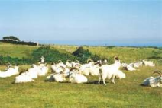 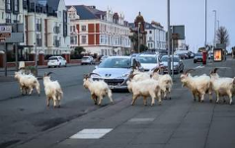

**What does a Kashmiri goat look like?**

Kashmiri goats have long horns. Their coats are soft and are the material Kashmiri wool. A few of the goats have dark facial marks like a triangle from beneath the eye to the mouth. The goats have cloven hooves that help them to climb steep mountains.

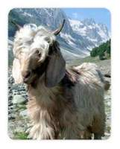

**What do Kashmiri goats eat?**

Kashmiri goats eat brambles,ivy,hawthorn,stinging nettles and elder. Goats are herbivores this means they eat plants. They feed their young on milk.

**Other interesting facts**

* + GOATS ARE MAMMALS
  + THERE YOUNGS ARE CALLD KIDS
  + THE MALES ARE CALLED BILLIES AND THE FEMALES ARE CALLED NANNIES
  + WILD GOATS TYPICLLY HAVE A LIFE SOAN OF 9 TO 12 YEARS