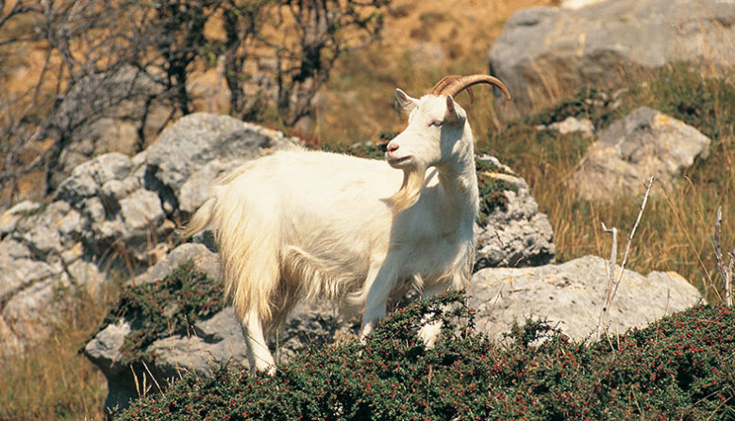
THE GREAT ORME KASHMIRI GOATS
The goats are wild animals, they were a gift to Lord Mostyn from Queen Victoria and live on the Great Orme.
Appearance.
The goats grow to 60 cm tall. They have large ears. Their wool is thick. The Billy goat has long, curved horns.
Habitat.
They live above sea level. Goats climb steep cliffs. Some goats dig holes to sleep in and have a dust bath.
Diet.
Goats are herbivores. They eat elder, hawthorn, bramble, ivy, nettles and privet.
Other information.
Wild goats have a life span of 9 to 12 years. They are very sociable and live in herds.

