Frozen by Fear

By Gracie Paterson

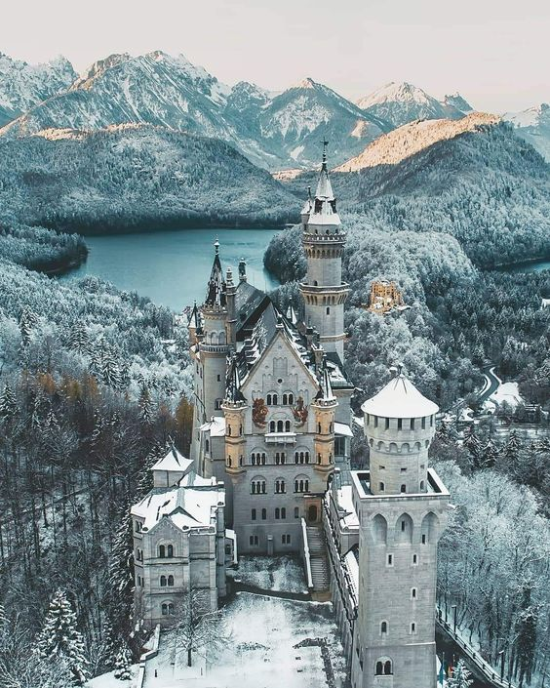

On a cold icy morning I took a small wooden rowing boat across the mystical, magical lake with my Mummy. I heard the howling wind rushing against my ears, then it gets colder so I pulled my furry cloak tight around my neck. It was hard to see because if was so foggy. Suddenly our boat bumped against the shore, we carefully climbed out of the boat.

We made our way through the frozen forest. Icicles hung like daggers from the trees as if warning us to turn back. I jumped onto my mummy’s back, we ran as fast as lightening through the enchanted woods. The trees began to clear and then my Mummy and I froze in amazement to see a magical mystical castle frozen in time.

We approached the castle, I knocked on the icy cold door, there was so answer, I then leaned against the door, suddenly it swung open, whoosh. Nervously we stepped inside. No one was there we crept through the hallway we found another door. As scared as we were we had to open the door for a glimpse of what was really inside the castle. It took a while for our eyes to adjust to the dark, slowly we could make out people at the back of the room.

As we walked closer we realised that everything was old fashioned, the king and queen had been turned into frozen statues. It was if a spell had been cast. We rushed in front of them, we waved our hands in front of their faces, we realised they were frozen. I then touched one figure it blinked, as if the people were trapped inside.

We could make out a crying sound coming from the tallest turret. We followed the sound coming from above, we followed the sound to a room to discover a baby Princess in her crib. A kitten was talking to the Princess, the baby was crying with sadness in her eyes filled with tears.

We said to the kitten that cat’s don’t talk. “Nonsense” said the kitten, “my mum was a human, and so was I once, but I was changed into a cat when everyone else was frozen.”
“But who froze you all?” I asked.
“It was the Wicked Witch, 5 years ago, she cast a spell on us all, she wanted to steal the baby for her own because she can’t have a baby,” the cat told us.
“So why weren’t you and the baby frozen?” I asked.
“Because we hid up here, and all the people who worked in the palace weren’t frozen but they turned into animals. I was the maid and I rescued the princess.” She replied
“How can we change you back?” I asked.
“There’s no way I’m afraid,” said the cat, “the only one who can save us is the Fairy Godmother.”
“But how do we find her?” I said.

“Isla it’s time I told you,” my mummy said, before transforming into a magnificent fairy, “I am the Fairy Godmother.”
“Why didn’t you tell me before? “ I asked confused.
“Because my magic only works in this kingdom. I got a message telling me that the King and Queen needed my help.”

She then turned me into a Fairy, suddenly I was flying and I had a wand in my hand. One by one we started to unfreeze everyone. The King and Queen said “thank you so much” as they held their baby tight.

After that we lived happily ever after, as fairies.

The End

