The empty house
Cara: hey billy I heard there is an empty abandoned house over here wanna go explore
Billy: I do not know are you sure it is empty looks like there might be some monsters in there
Cara: do not be a wimp billy there might be some valuable things in there
Billy: ok lets go in, but can you go first
Cara: oh billy man up
Billy: …
Cara: (crawls over the fence and opens door) where to start
Billy: lets go to the library maybe it will have a hidden room behind a bookcase
Clara: k lets go then
Clara+Billy: (walk to library)
Billy: I am gonna pull out all the books (pulls out books)
Billy: nothing here
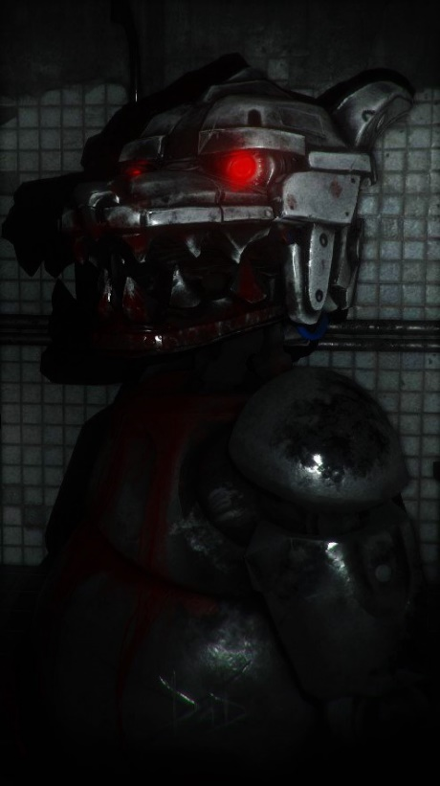
suddenly the pair heard heavy footsteps coming towards them the footsteps were getting louder and faster when some robot wolf dashed towards them it was terrifying they dashed out of the building as soon as possible and luckily they escaped the house lucky for them the door was blocked with rubble and the thing couldn’t chase them they decided they were not going to sneak into houses anymore

