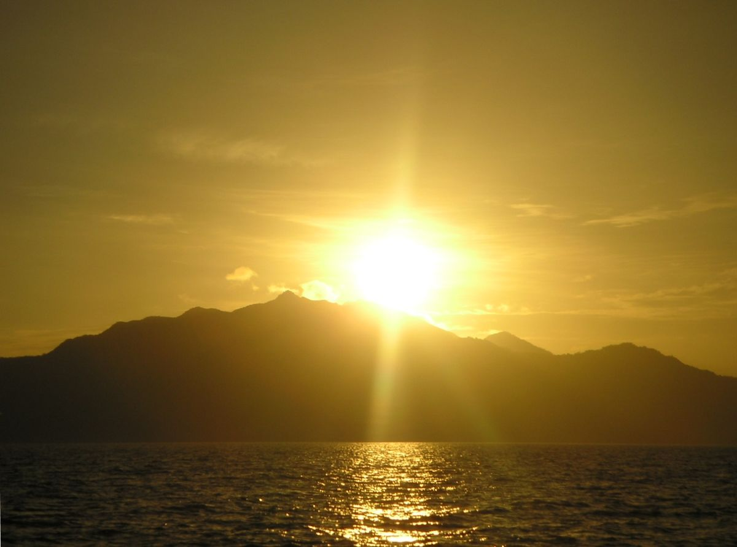
MORNING

Birds tweeting
Sun rising
Parents yawning
Children laughing
Cars driving
Curtains opening
Radios blaring
Dogs stretching
Showers flowing
Bins clattering
Toast popping
Busses leaving
People fishing
Cyclists whizzing
Dandelions blowing
Morning
By Emily. E

