**Rode Heath Primary School: Week 5 Challenge day 4: Charlie Mackrory Year 2.**

**English:**

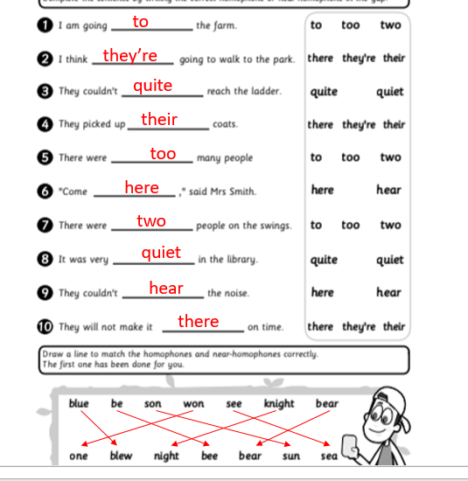

**Maths**

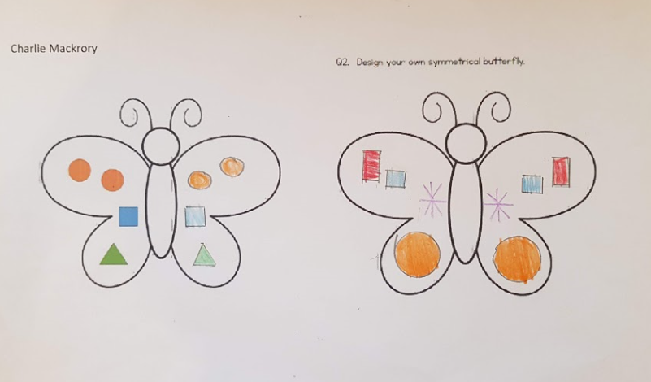

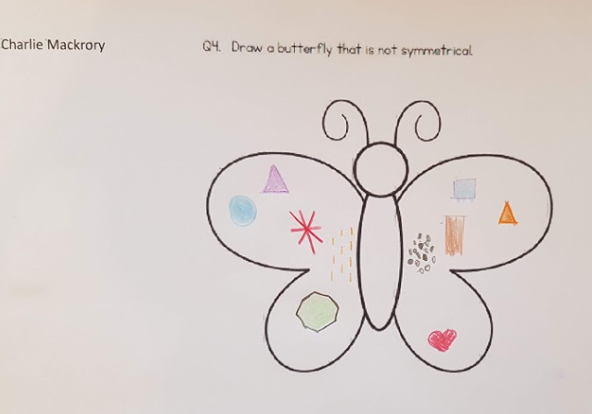

**Charlie completed the following maths first by mistake (he actually enjoys it than much ;o))**

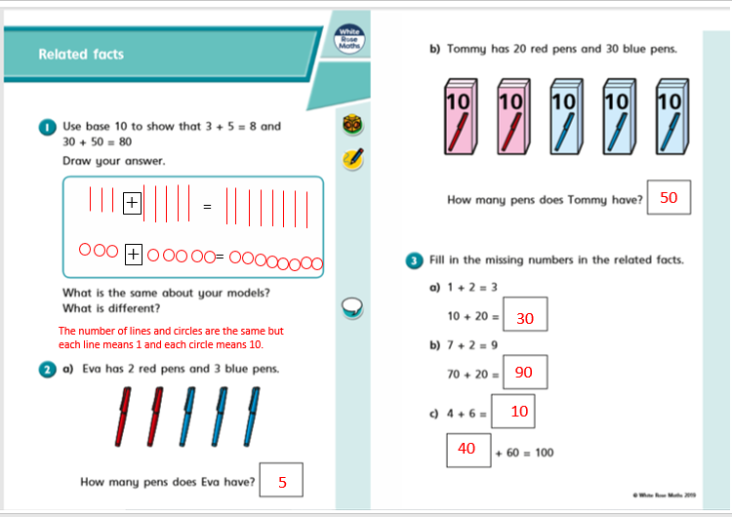

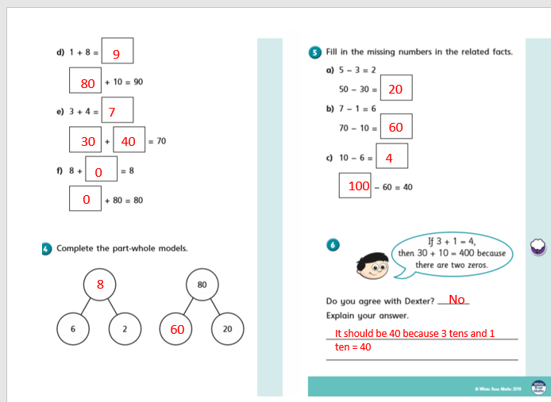

**French:**

