Rode Heath Primary School: Week 5 Challenge day 2: Charlie Mackrory Year 2.

English:

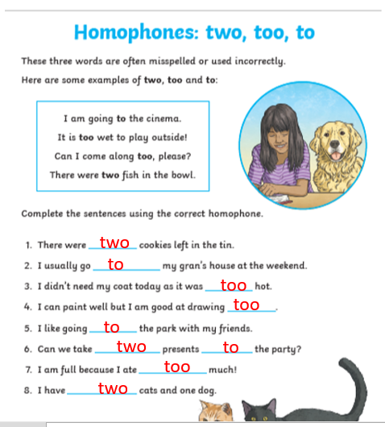

Maths:

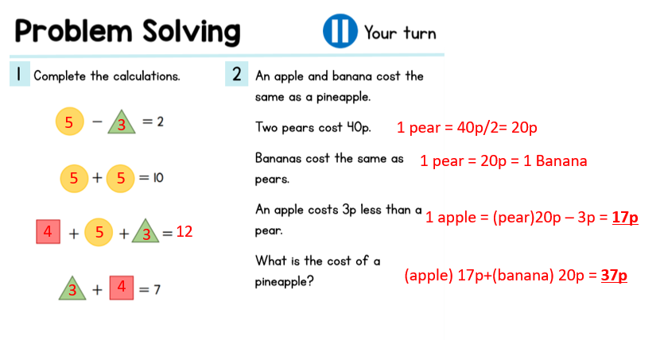
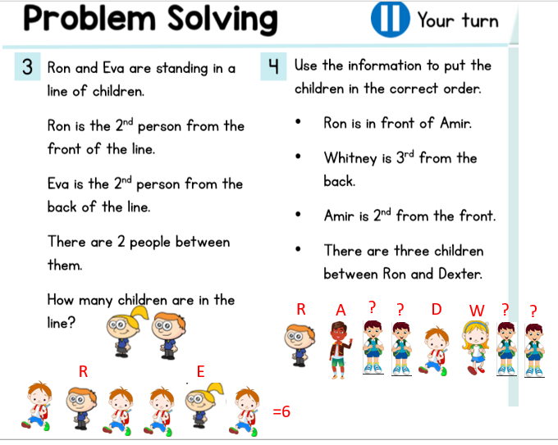

3/4

