**Rode Heath Primary School: Week 5 Challenge day 1: Charlie Mackrory Year 2.**

**English:**

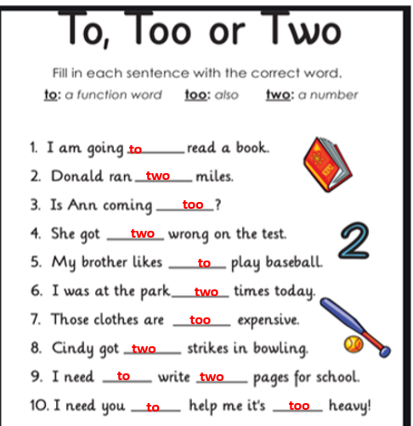

**Maths:**

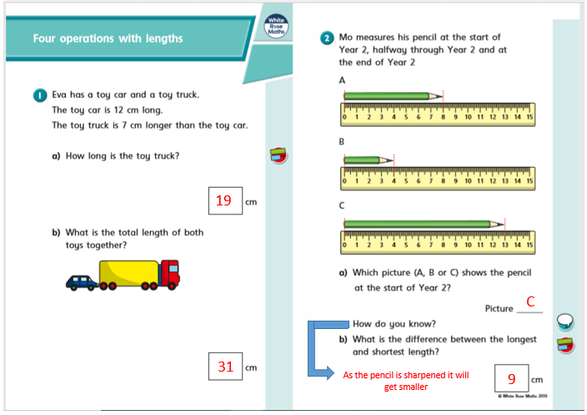

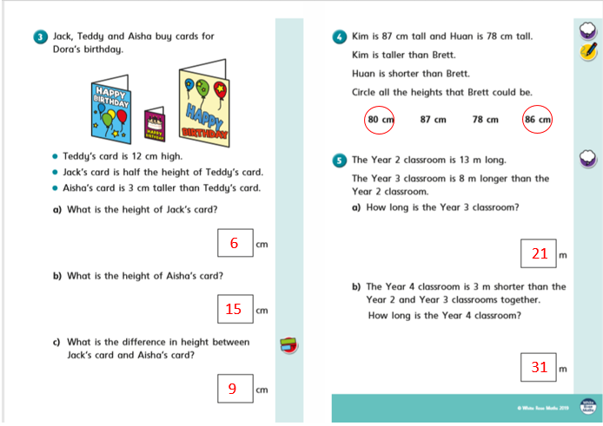

**Geography:**

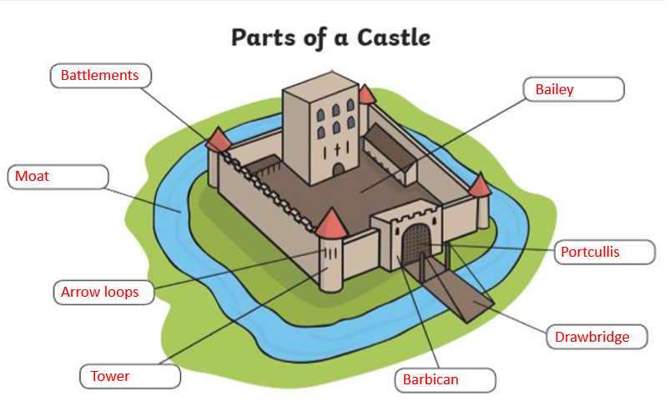

3/4