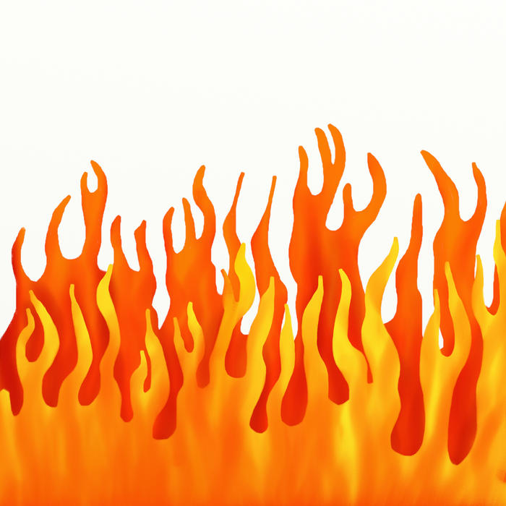

**As I stand next to the night *burring* fire I see sparks rise high in the sky like fire flies. Dancing Flames, flicker and twitter on the logs, the Logs go “pop” like corn hopping and popping in a pan.**