Rode Heath Primary School: Week 3 Challenge day 1: Charlie Mackrory Year 2.

English:
Today I would like you to write your own round/s based on the rhythm and tune of ‘London’s Burning’. You will need your verb table from Week 2 Day 4 to help you.

Verbs | Present Tense
jump | Jenny’s jumping
cry | Charlie’s crying
play | Charlie’s playing
run | Charlie’s running
hop | Charlie’s hopping
clap | Charlie’s clapping
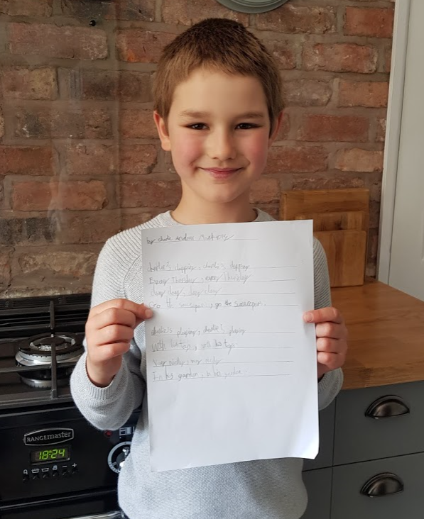

Maths:
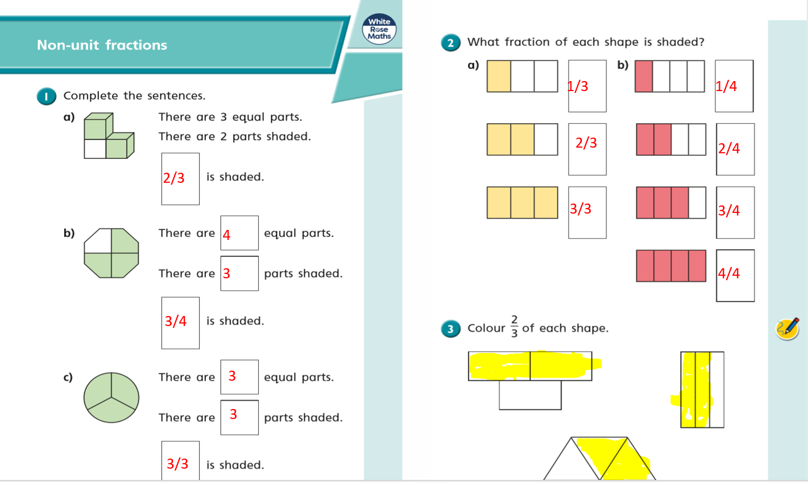
3/4

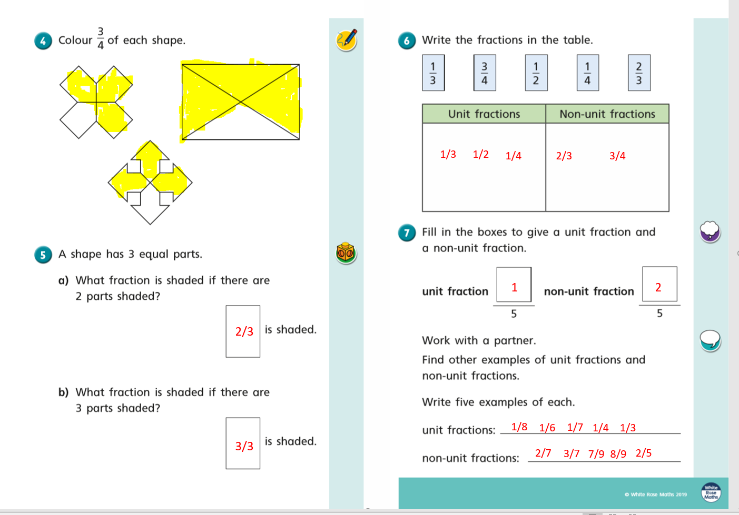

Art:

