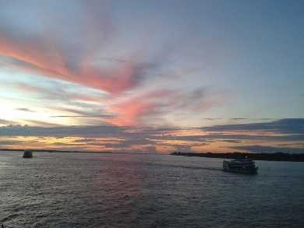
Amazon, Rhine and Ganges
Amazon

The Amazon River is in South America and is the largest river by discharge volume of water in the word and is the 2nd largest river. It is 6,400 km long the river was made about 11 million years ago and took its present shape 2.4 million years ago.
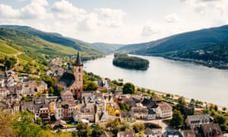
The Rhine
The Rhine runs through Germany it is 150 metres wide and 20 – 25 metres deep. The rhine is 5 million years old it was made in 1806.

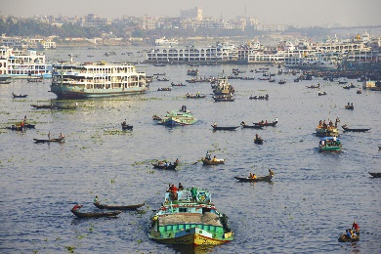
The Ganges
Flows through India and Bangladesh. Its 2,601 km long

The Ganges is a lifeline to millions who live next to it. It is a sacred river and worshiped as the goddess Ganga
The Ganges is polluted. This is a danger to people and to animals. The Ganges is home to about 140 types of fish and 90 types of amphibians. The river also contains reptiles and mammals, including gharial and South Asian river dolphin.

