Rode Heath Primary School: Week 2 Challenge day 4: Charlie Mackrory Year 2.

English:
Can you change the words below by adding ‘ing’ – present tense and then by adding ‘ed’ – past tense? Be careful, some you just add ‘ing’ to and others you need to double the last letter then add ‘ing’,
Verbs | Present Tense | Past Tense
Jump | Jumping | jumped
Cry | Crying | Cried
Play | Playing | Played
Run | Running | Ran
Hop | Hopping | Hopped
Clap | Clapping | Clapped

Next week these verbs will be useful in your own round. To fit in with the rhythm, they need to be 2 syllable names. (Har-ry, Jen – ny, Soph-ie). Tom is a one syllable name so this is no good. For example, Jenny’s jumping, Jenny’s jumping. Now add 2 syllable names to your verbs.
Verbs | Present Tense
jump | Jenny’s jumping
cry | Charlie’s crying
play | Charlie’s playing
run | Charlie’s running
hop | Charlie’s hopping
clap | Charlie’s clapping

Maths:
Today I would like you to complete Week 2, Lesson 3 – Unit Fractions
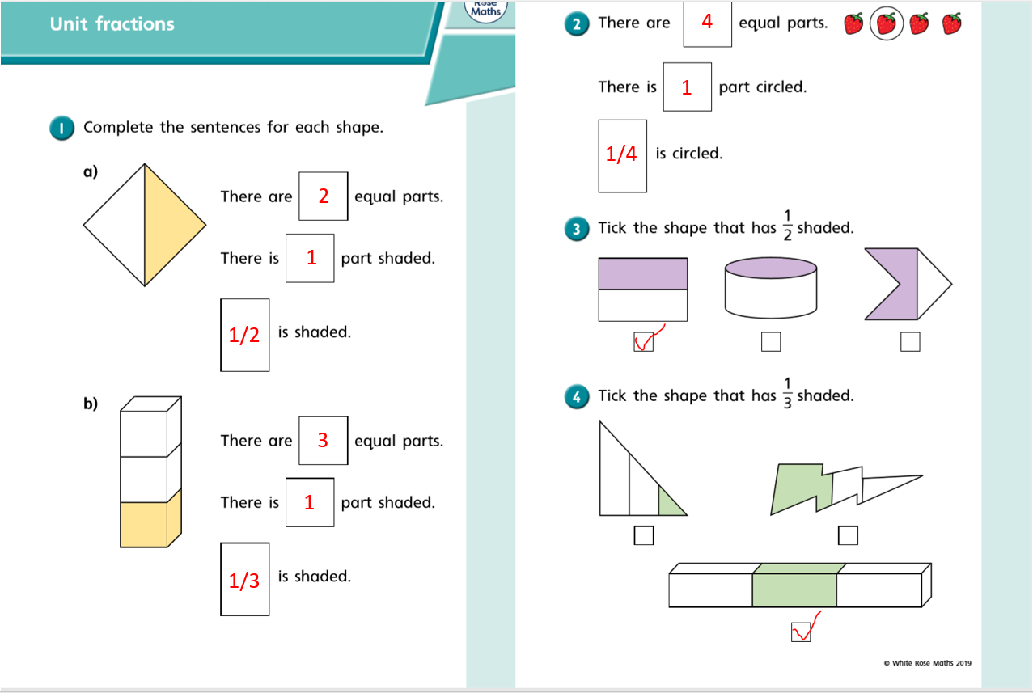
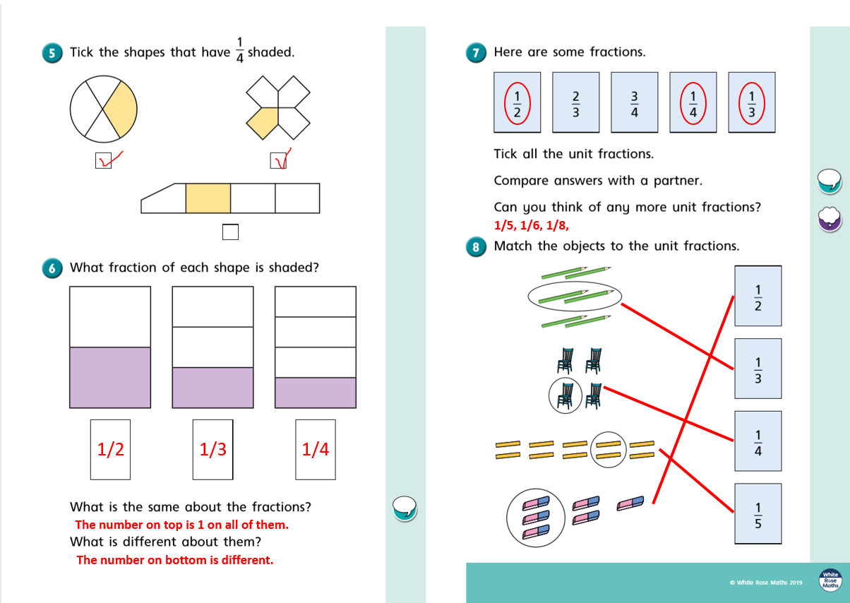

Religious Education
The Parables – Stories that Jesus would have told.
Your task last week was to read the story (parable) of the Lost Sheep or watch a clip on YouTube.
This week I would like you to retell the parable of ‘The Lost Sheep’. Here is a storyboard template to help you if you wish to use it.
