Rode Heath Primary School: Week 2 Challenge day 3: Charlie Mackrory Year 2.

English:
Ques. 1 – What are they helping to express here in this poem? Panic, fear, surprise, shock
Ques 2 – Why do you think London ’s burning nursery rhyme is still sung today? So people can remember it
How has it survived time? Why hasn’t it just been forgotten about? It is easy to remember as it is a song which keeps repeating the same words.

Maths:
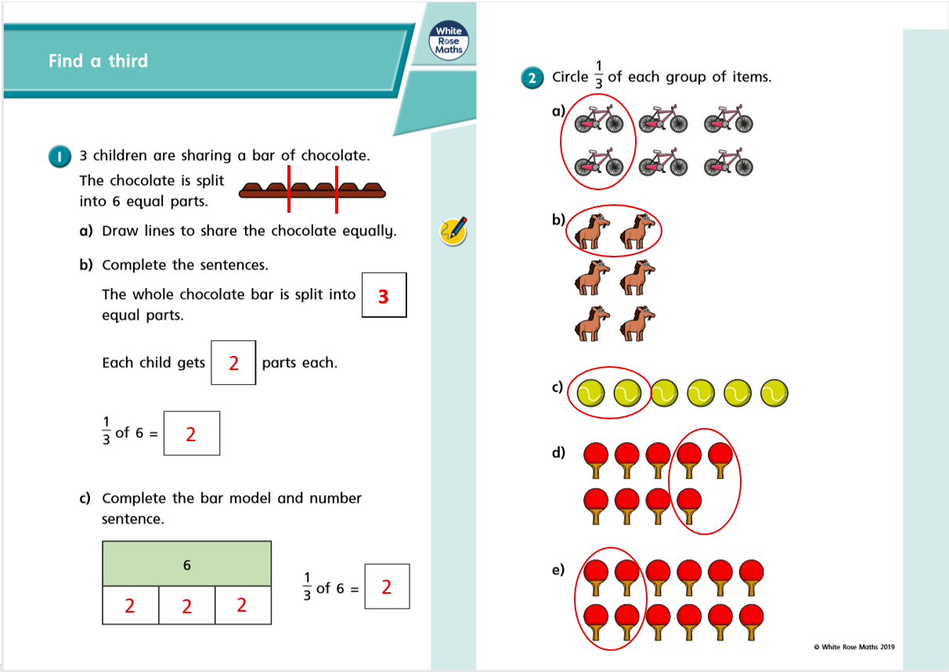
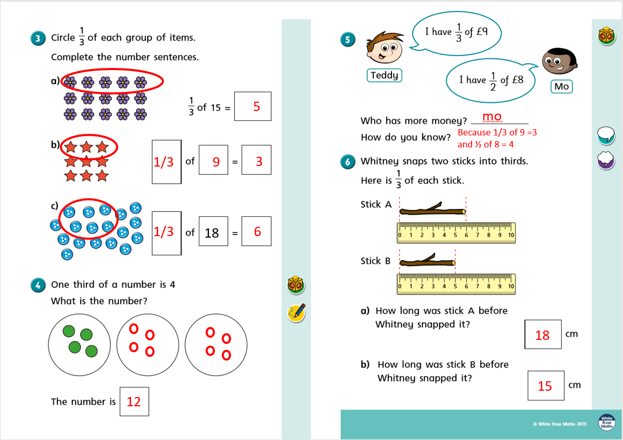

Science:
This week I would like you to fill in your bean diary again and see what has changed. Measure your plant and write on your picture how tall it is. Write the date on your picture.
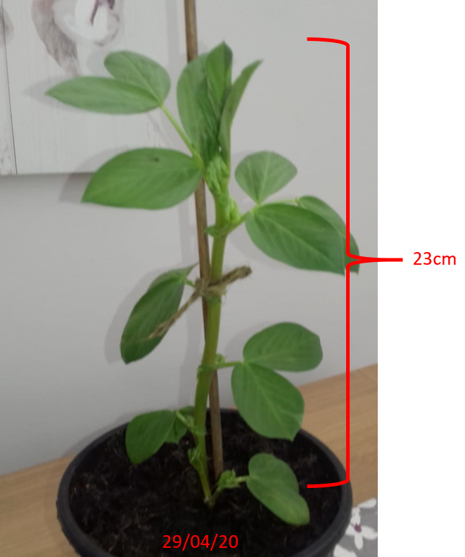
Here is your challenge question for this week. Look at these different seeds below:
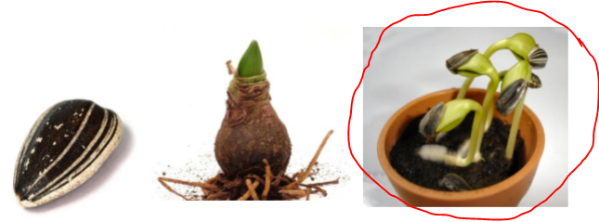Which one is the

Odd One out and why?
This is the odd one out because the seed has grown into a plant already

