**Rode Heath Primary School: Week 2 Challenge day 1: Charlie Mackrory Year 2.**

**English:**

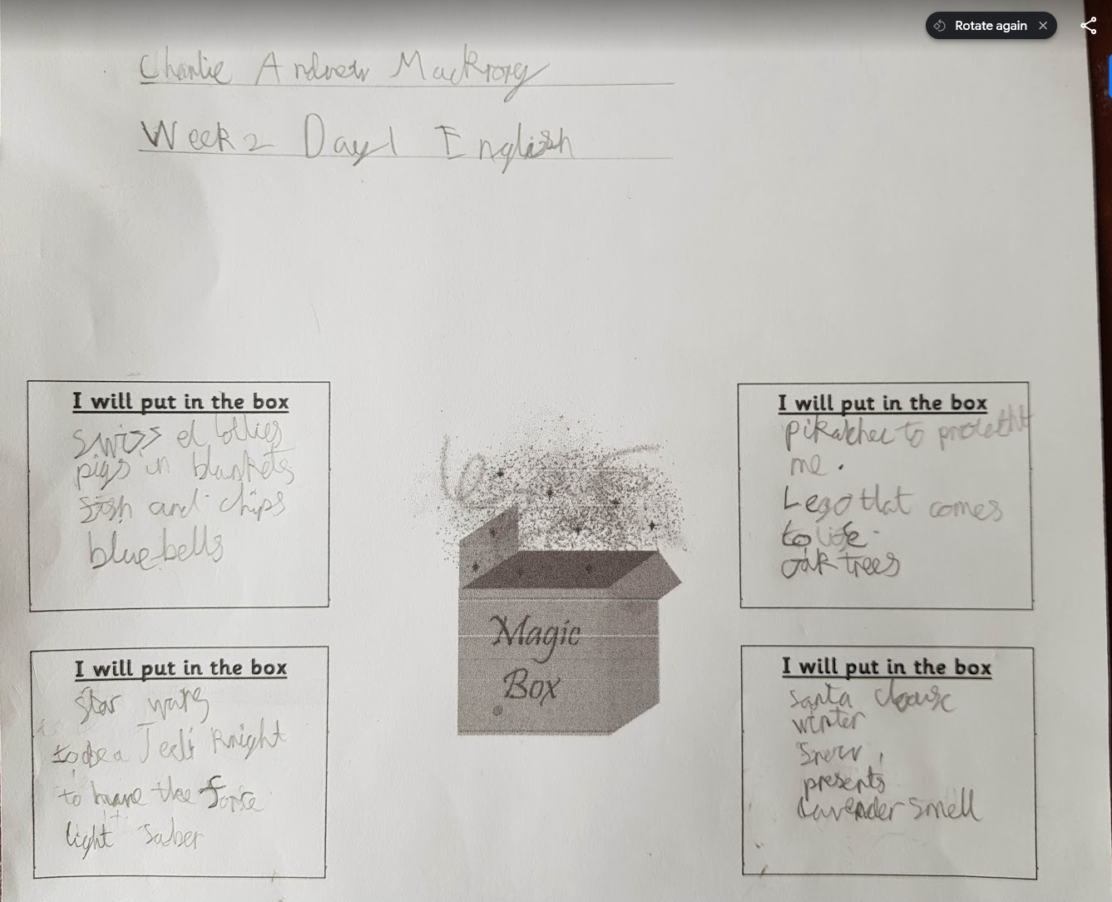

**Art:**

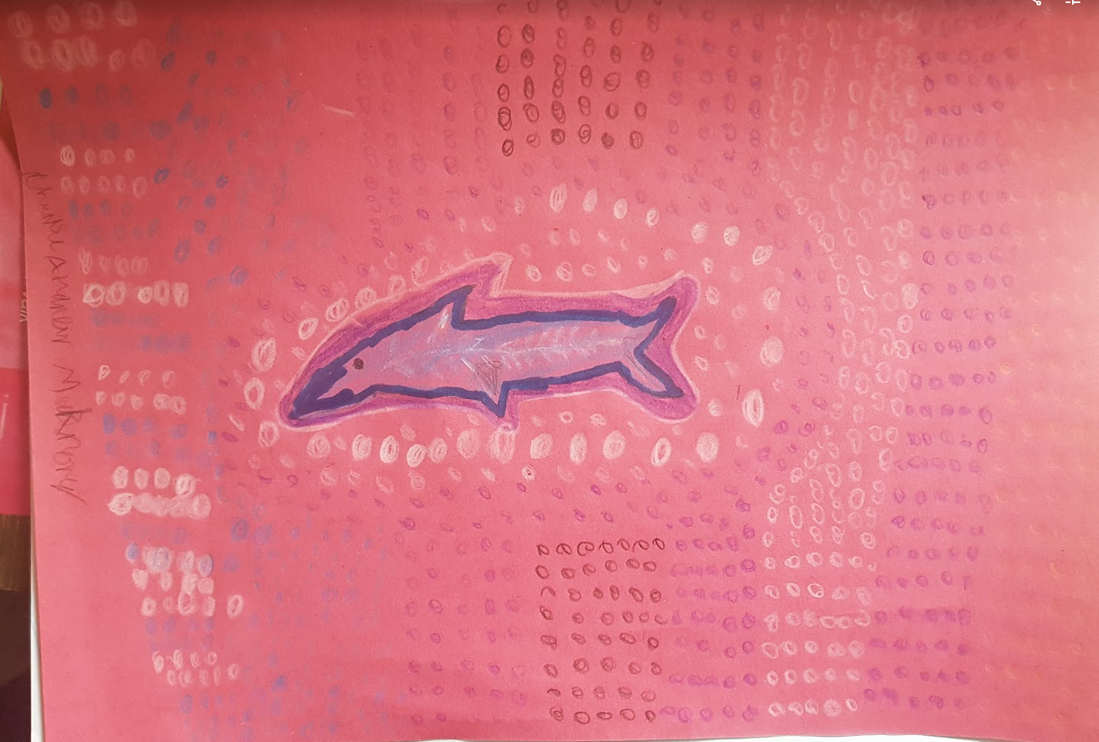

**Maths:** 