The Orca Whale

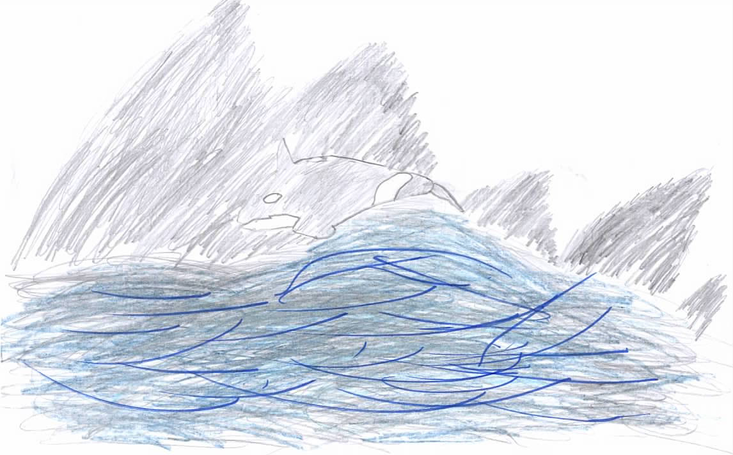
By Henry Meneghin

The Orca (Killer Whale) are found in Norway Spyildra and are part of the dolphin family orca have a larger fin than Whales and have less of a squirt of water. They can cover 100 metres in a day, they squeak and squeal to communicate navigate and hunt. They are black and white, they eat herring and the bond between child and mother is so strong that they stay together for life. They have the second smartest animal brain on earth and they find and follow the fishing boats and eat the herrings that spill out of the net. They use their squeals for hunting because the sound waves bounce back off the Shoals of fish and they swim towards them. And they live in Norway because there is more seals and herrings plus the blubber would make it too hot to live in warmer water.

