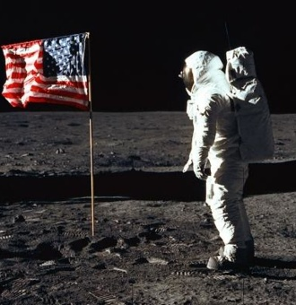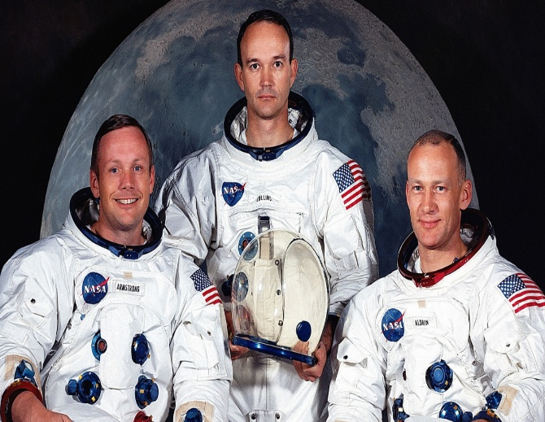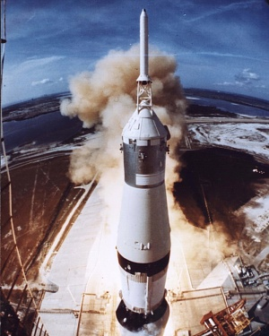

**Landing On The Moon**

Although Armstrong was the first to step on the moon Buzz Aldrin was the first to wee on the moon!

The USA won the great Space Race against Russia.

Neil Armstrong became the first man to walk on the moon and said "That’s one small step for man, one giant leap for mankind." He was meant to say “for a man” but forgot “a”. They spent 21 hours on the moon before coming back to Earth. They collected samples of moon rocks and dust, and also took lots of photos.

The landing site chosen was an area called the Sea of Tranquillity because it was smooth and safe. On 20th July 1969, Armstrong and Aldrin became the first humans to land on the moon, while Collins stayed in orbit around the moon. The special landing pod they used was called ‘The Eagle' . It was so small there were no seats.

On 16th July 1969, three American astronauts, Neil Armstrong (26), Buzz Aldrin (22) and Michael Collins (28) went up to space. The Apollo 11 set off from Florida USA on a mission to get to the moon. First the spacecraft travelled through space for 3 days until reaching the moon.