Rode Heath Primary School: Charlie Mackrory Year 2.
Challenge 3:
English:
English Today I would like you to read 2 poems with simple repeating patterns.
1. Wings by Pie Corbett
2. See me Walking by Clive Webster Can you spot the patterns in the poems?

onto a piece of paper.
On the way to school I saw…

On the way to school I saw children running along the pavement.
On the way to school I saw houses stood still
On the way to school I saw cars zooming past
On the way to school I saw friends playing tag
On the way to school I saw birds flying in the sky

Maths:
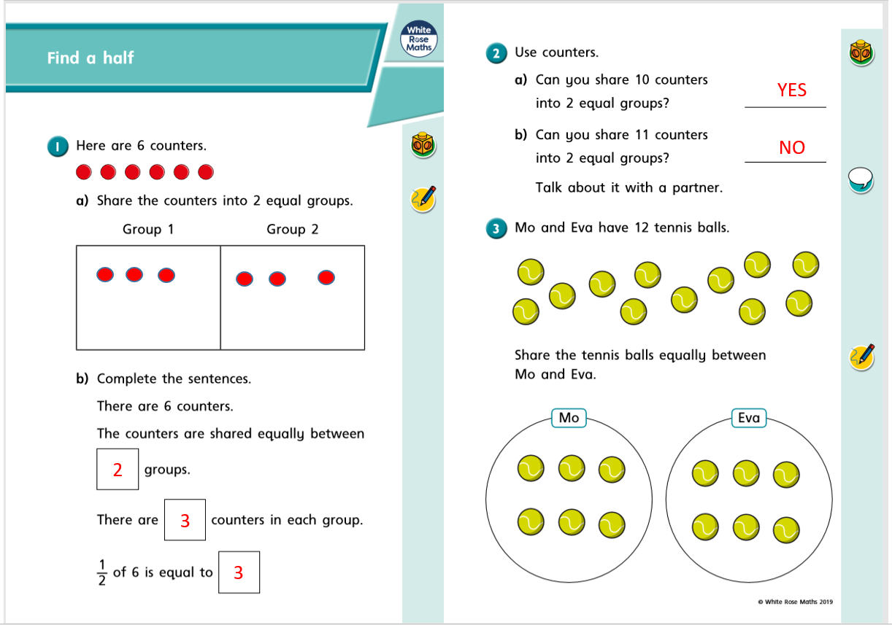
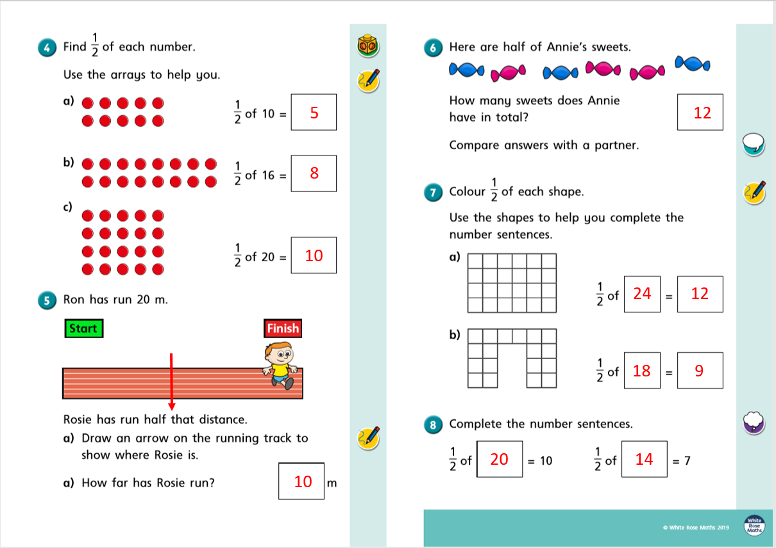
Science:
Science – From Mrs Wiskow Challenge 1 – Investigating Seeds
Dear Year 2s, I have heard from Miss Moss that you are all trying to grow broad beans at home. How exciting! For your first task I would like you to draw a labelled diagram of your broad bean plant clearly showing the different parts.
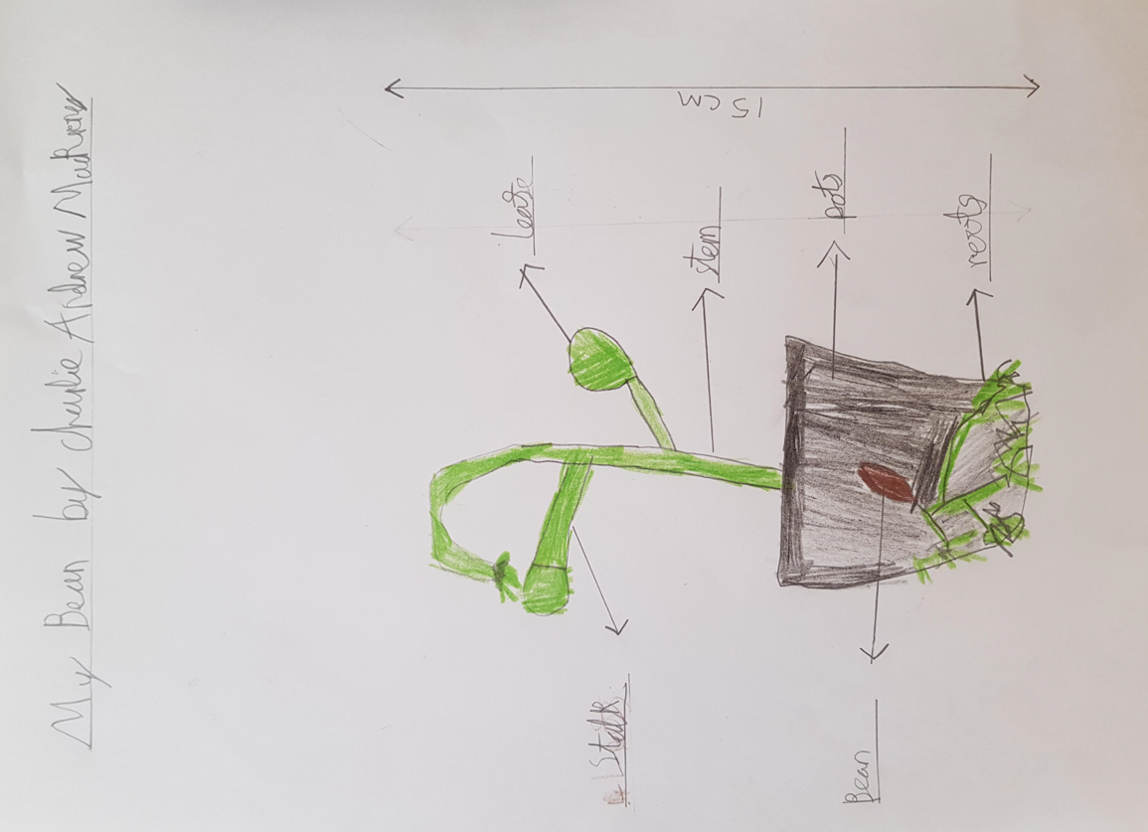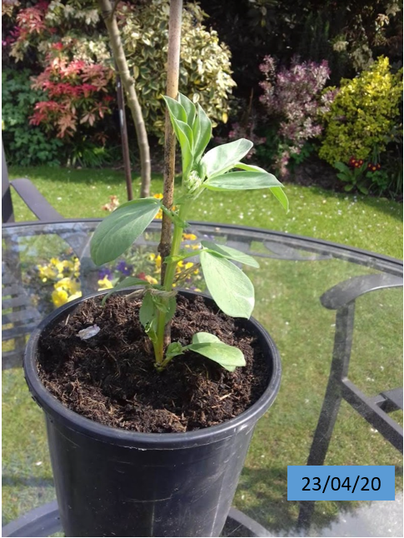

Measure your plant and write on your picture how tall it is. Write the date on your picture.

