 | Rode Heath Primary School  Heath Avenue, Rode Heath,  Stoke on Trent, ST7 3RY  Telephone: 01270 314414  E-mail Address: admin@rodeheath.cheshire.sch.uk  Headteacher: John Frankland  Inspiring learning; nurturing minds; achieving for life | 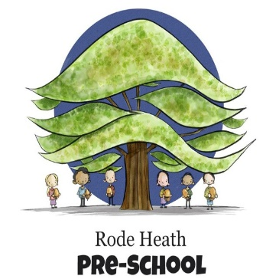

Thursday 21st September, 2023

Dear Parents/Carers,

This term our history focus is on Ancient Egypt and to enhance the children’s experience of this fascinating period, we have booked a trip to the Macclesfield Silk Museum on Monday 2nd October. The day will consist of three workshops, including a tour of the exhibition run by Miss Marianne Brocklehurst (in costume), an object handling session where the children are curators, and an Anubis mask making session.

We will be leaving school at 9:15 am and should be back for the end of the school day, depending on traffic. The cost of the trip will be £20, payment and consent can be made via yor scopay account. The children will need a packed lunch and a couple of drinks (no cans or glass bottles please!) in a suitable hands-free bag such as a rucksack. The children need to wear school uniform and bring a waterproof coat.

Kind regards

Mrs Wiskow & Mrs Pecora

