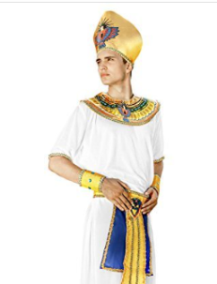Dear Year Four children, parents and carers,

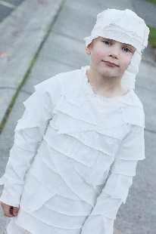We have an exciting event coming up:

**Egyptian Day!**

**This is a wonderful enrichment day crammed with learning activities for a fun-filled Egyptian inspired experience on Monday 20th November.**

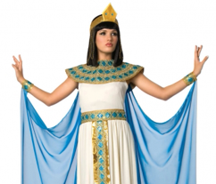To help immerse themselves in the day, we would like your child to wear an Egyptian-inspired costume. (Please don’t go to too much expense though – home-made outfits can be just as good). The more creative, the better. There will be prizes for the most original ideas!

The day will include:

Food preparation; Science (mummifying); and Art.

**We are planning to design our own hummus recipes, so would be very grateful if we could borrow some blenders for our food preparation session. Also, if there are any parents/grandparents out there who are able to assist in this session from 1.30 to 3pm, please let us know.**

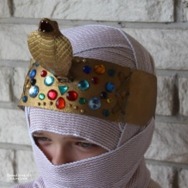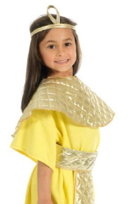

NB There will be a small charge of £2 to cover the cost of the food. You will be able to pay this online using the usual payment method.