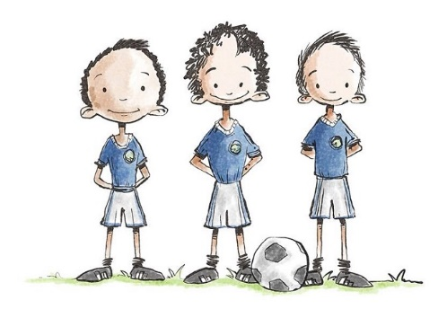

**Rode Heath Primary School**

**Sporting Ambassadors**

**Job Description**

**Rode Heath Sporting Ambassadors require a lot of qualities, below are a list of qualities and some job descriptions required when taking up the role of a Sports Ambassador:**

**Qualities/Skills Required**

* **Must be approachable and have a good relationship with all children**
* **A positive role model and an excellent attitude towards learning and playing sports**
* **Be a good team member**
* **Able to engage and inspire others**
* **Must be organised and be a good timekeeper**
* Well-presented in uniform and appearance

**Our Sporting Ambassadors have been carefully chosen and show all of the qualities above. We will have nine ambassadors in total, three children from Year 4, from Year 5 and from Year 6. Their job role is very important throughout the school and below you will see a list of jobs our Sporting Ambassadors will undertake throughout the school year**.

**Jobs:**

* **Advertise and promote healthy living, including daily exercise and healthy snacks in and around school**
* **Run break/lunch time activities on the KS1 and KS2 playground**
* **Help run and organise Intra house competitions**
* **Be ready for other Sporting needs throughout the year**
* **Raise the profile and to be ambassadors of the daily mile**
* **Regularly update the school in assemblies and on the sports noticeboard on our performances in school competitions**

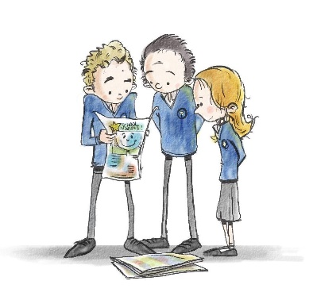

**Rode Heath Primary School  
School Councillors**

**Job Description**

**Rode Heath School Councillors require a lot of qualities, below are a list of qualities and some job descriptions required when taking up the role of a School Councillor:**

**Qualities/Skills Required**

* **Must be approachable, a good listener and have an excellent relationship with all children**
* **A positive role model, kind and caring and a good attitude towards learning and has exemplary behaviour**
* **Be a good team member**
* **Must be organised and be a good timekeeper**
* **Must be confident and speak clearly**
* **Willing to bring ideas to meetings, listen to others and to be realistic about what can be achieved**
* **Willing to give up your own time to help, come to meetings or prepare something**
* Well-presented in uniform and appearance

**Our School Councillors have been elected by their class peers through a fair election process. We will have 14 School Councillors in total, two children from each year group apart from year 6 where there will be four representatives. Their job role is very important throughout the school and below you will see a list of jobs our School Councillors will undertake throughout the school year**.

**Jobs:**

* **Take on the role of a junior safeguarding lead to help give advice to the children on matters such as e-safety, bullying and health**
* **Representing the voice of the children of Rode Heath Primary School**
* **Working with teachers to make decisions which will improve the school**
* **Attending meetings regularly and on time and** work closely with the School Council adult.
* **Listening to and collecting ideas from your class and sharing them at council meetings**
* **Leading and helping in assemblies and class meetings**
* **Deciding on and organising events**
* **Representing Rode Heath Primary School both in school and out of school when called upon**

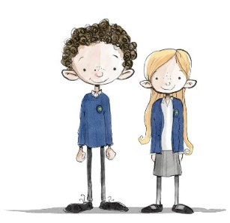**Rode Heath Primary School**

**House and Vice-House Captains**

**Job Description**

**Rode Heath House and Vice-House Captains require a lot of qualities, below are a list of qualities and some job descriptions required when taking up the role of a House or Vice-House captain:**

**Qualities/Skills Required**

* **Must be approachable, a good listener and have an excellent relationship with all children**
* **A positive role model, kind and caring and a good attitude towards learning and has exemplary behaviour**
* **Be a good team member**
* **Must be organised and be a good timekeeper**
* **Must be confident and speak clearly**
* **Willing to bring ideas to meetings, listen to others and to be realistic about what can be achieved**
* **Willing to give up your own time to help, come to meetings or prepare something**
* Well-presented in uniform and appearance

The role of House and Vice House Captains are ones of privilege, pride and responsibility. They are more than just a title and badge and require dedication and commitment for two years. Our Vice-House Captains are elected by their class peers at the end of year 4 through a fair election process. These children act as Vice Captains throughout their time in Year 5 and then become House Captains once they are in Year 6. At this point, the process of electing new Vice Captains begins again.

**Jobs:**

* Lead and support the children of your House in a variety of House Competitions
* Work closely with the House Lead teacher, providing ideas and support for competitions and House related activities
* Help organise and lead regular House Meetings
* Collect, monitor and announce House Points
* Inspire the children of your House
* Be an excellent role model in behaviour, attitude and dress at all times
* Act as corridor monitors during assemblies
* **Representing Rode Heath Primary School both in school and out of school when called upon**